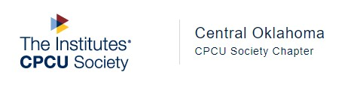



**CPCU/IIAOK Challenge Cup supporting scholarships for the next generation of insurance professionals**

**When:** Monday, 6/27/2022, 7:00 am registration; 8:00 am Shotgun Start

**Where:** Golf Club of Edmond, 4001 Fairfax Dr, Edmond, OK (405) 359-8333

**Entry Fee:** $75 per golfer with breakfast burritos, lunch, 2 drinks, green fee, ½ cart & range balls

**Mulligans will be available at the check-in table for $5 each**

**Tournament fees:**

$75: Individual Player

$275: Hole Sponsorship (includes two players)

$300: Team fee (four players)

$125: Hole Sponsor (no players)

Closest to the pin & longest drive sponsors; $200 each

Beverage Cart Sponsor: $500

**Please Submit Registration no later than 6/10/2022**

**Play is available in two categories with prizes for each:**

Real Golf___ Or Scramble___

Name: _____________________________________________

Agency/Company: ___________________________________

Address/City/State: __________________________________

Phone: _______________Email: ________________________

**Individual Golfers and/or Team Members (with handicaps):**

1. ______________________ 3. ________________________

2. ______________________ 4. ________________________

**Register online at: Centraloklahoma.CPCUsociety.org**

(Look under “Upcoming Events” click on Annual Golf Outing.)

**or**

**Register by mail and send this registration form and entry fee to:**

Central Oklahoma CPCU Society Chapter

P.O. Box 20867

Village, OK 73156